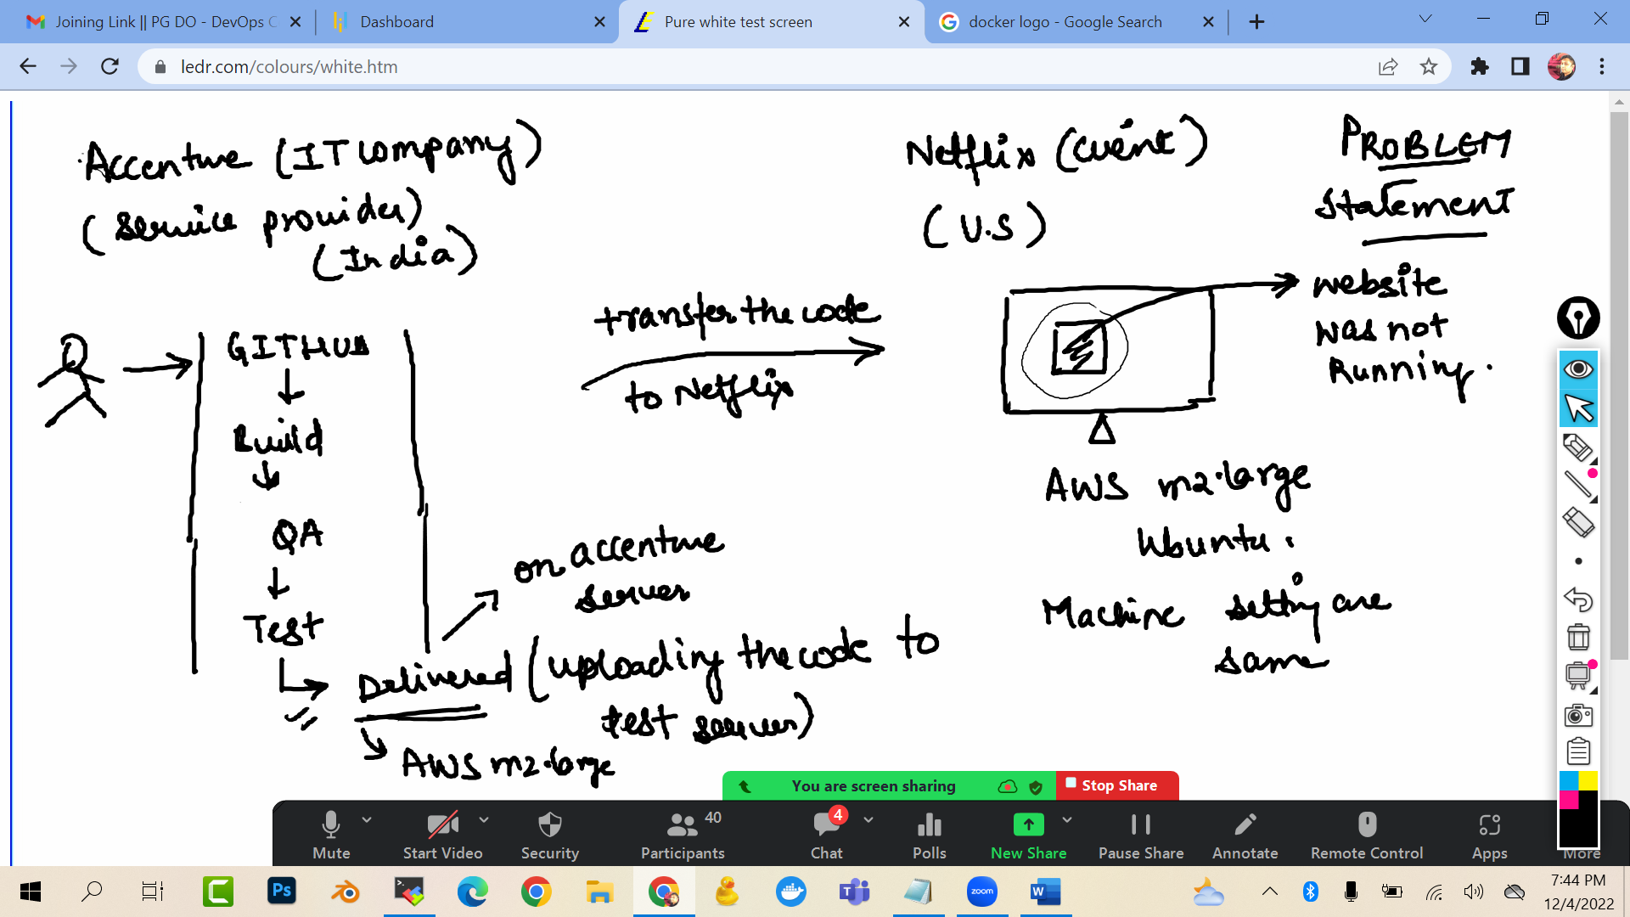

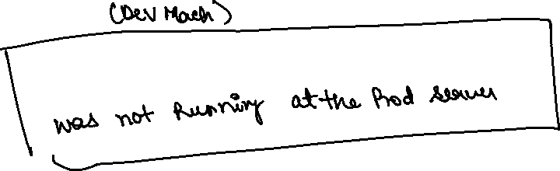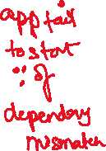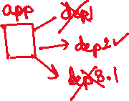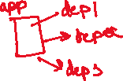

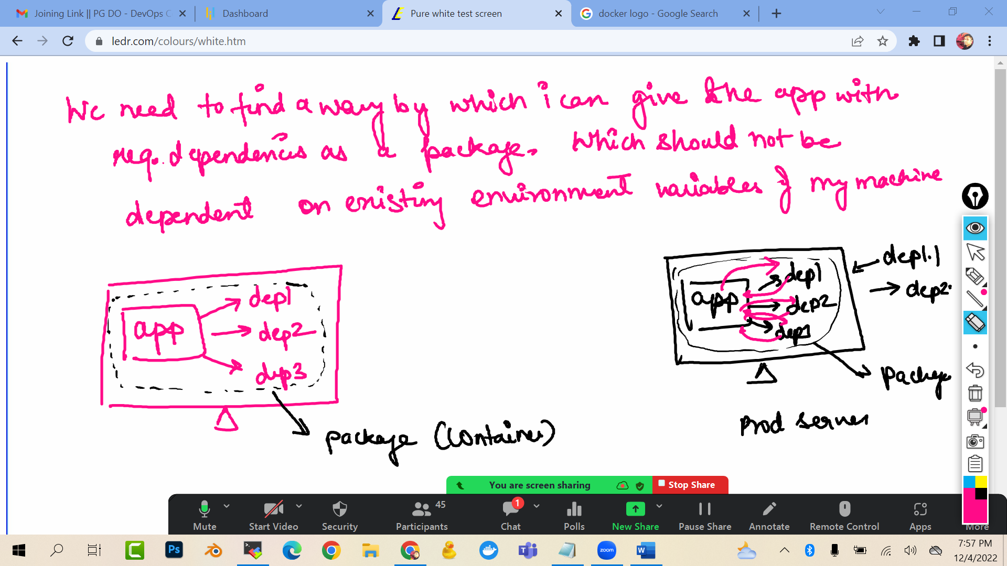

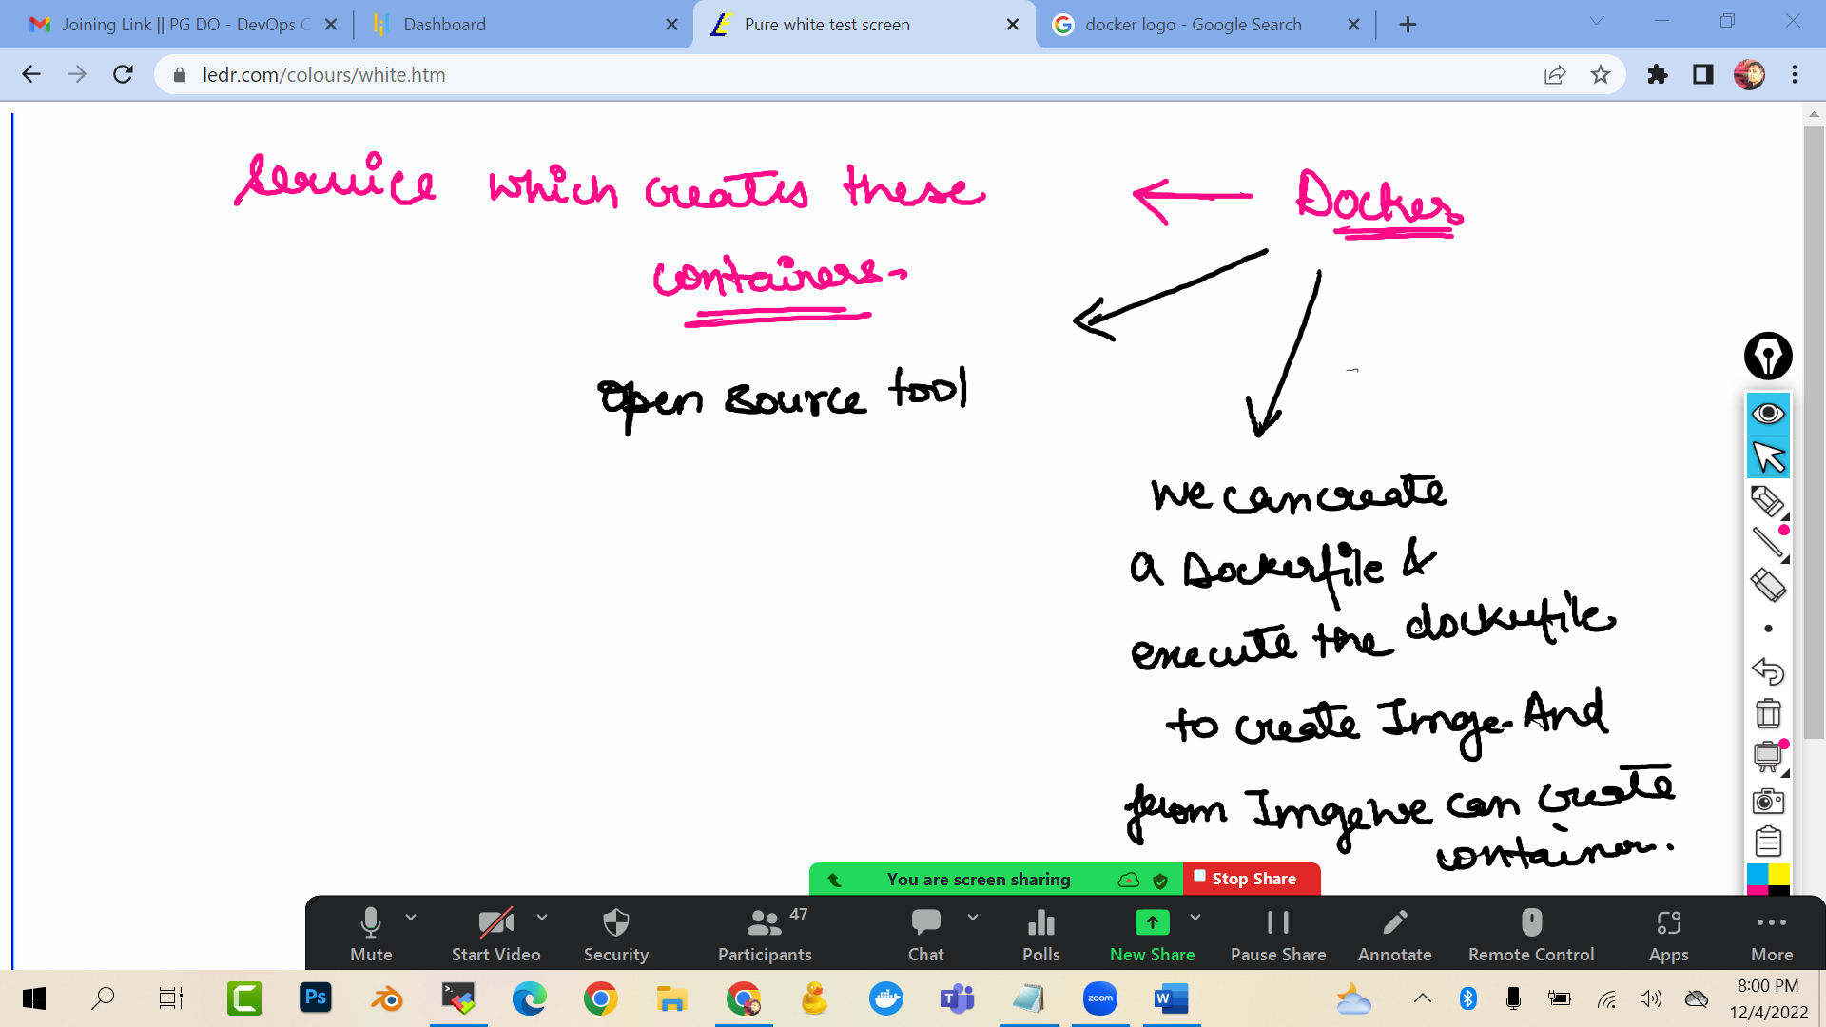

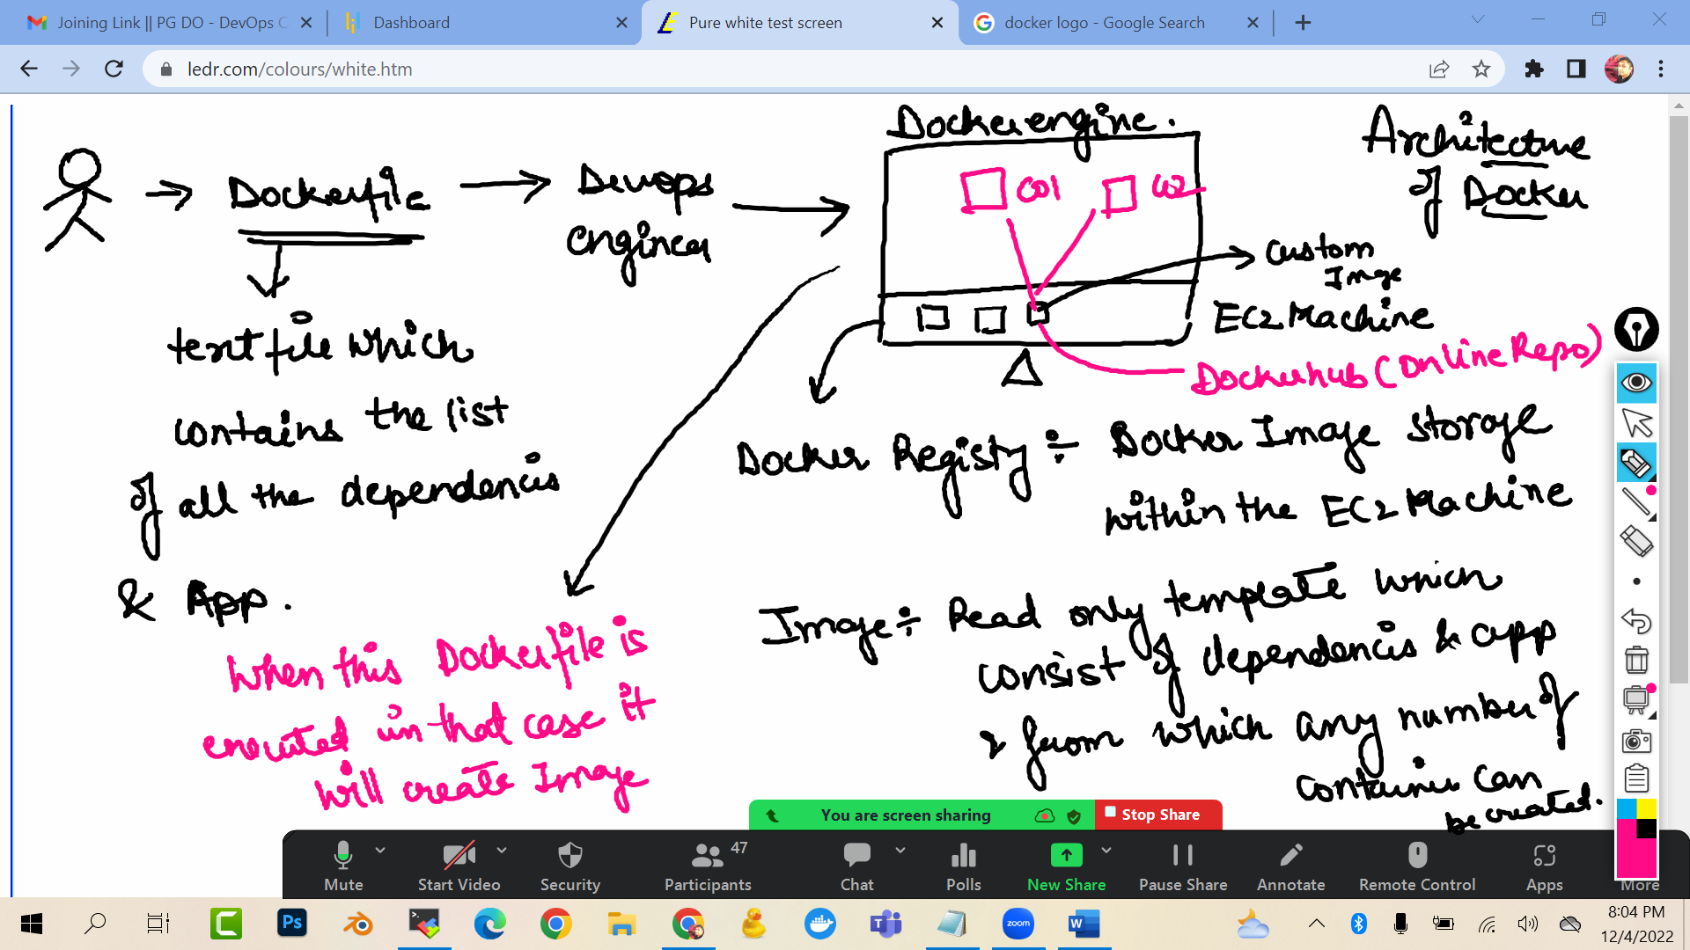

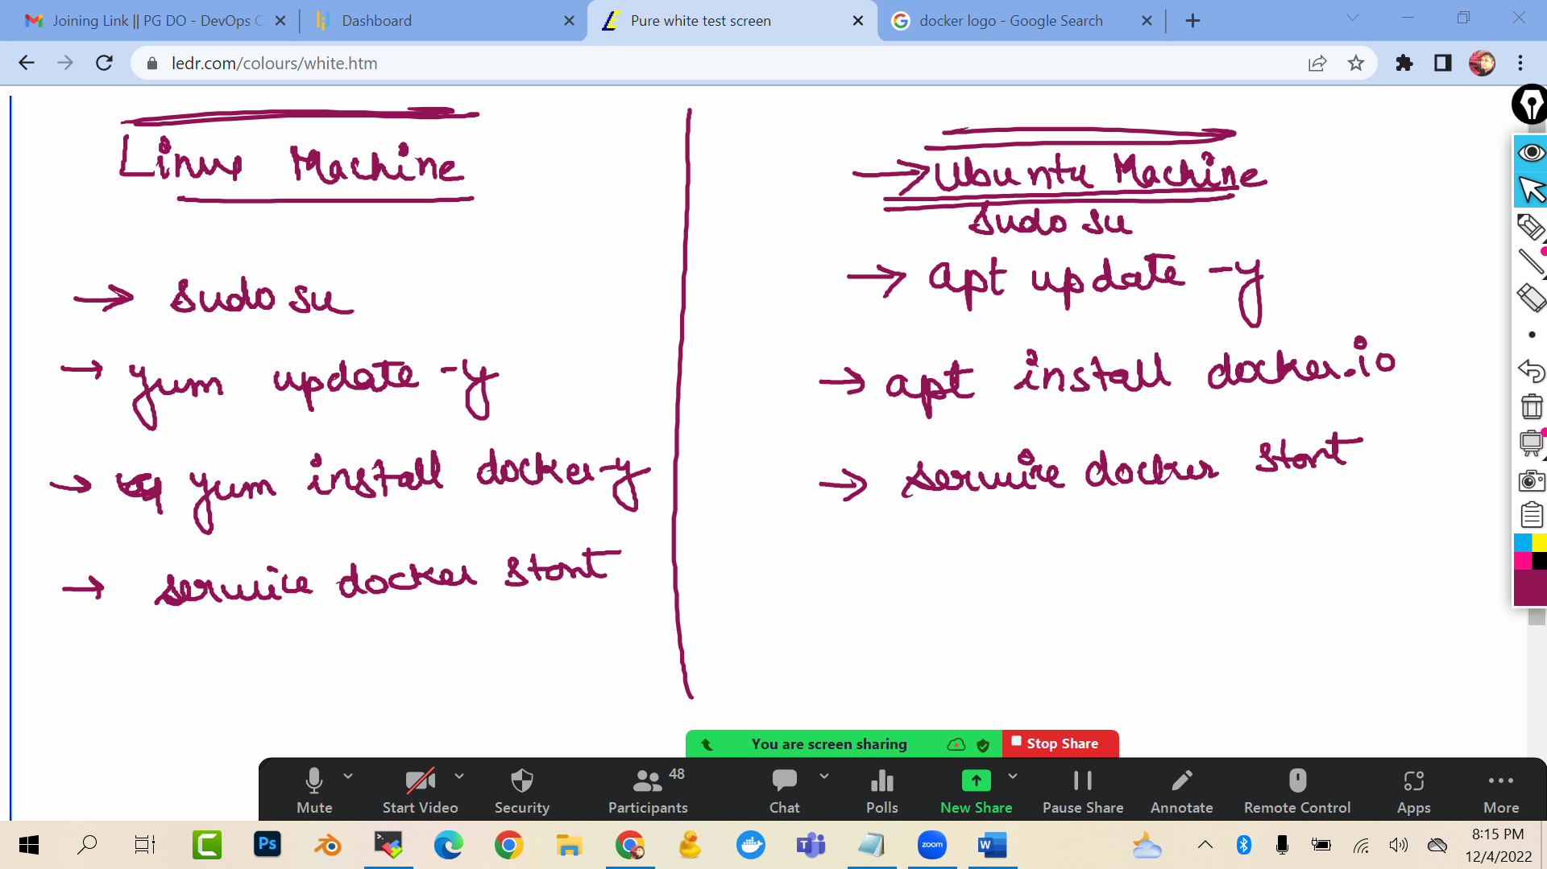

Launch a ubuntu ec2 machine

sudo su

apt update -y

apt install docker.io -y

docker --version

service docker start

service docker status

To check the images (read only template) in the docker registry (in ec2 machine)

docker images

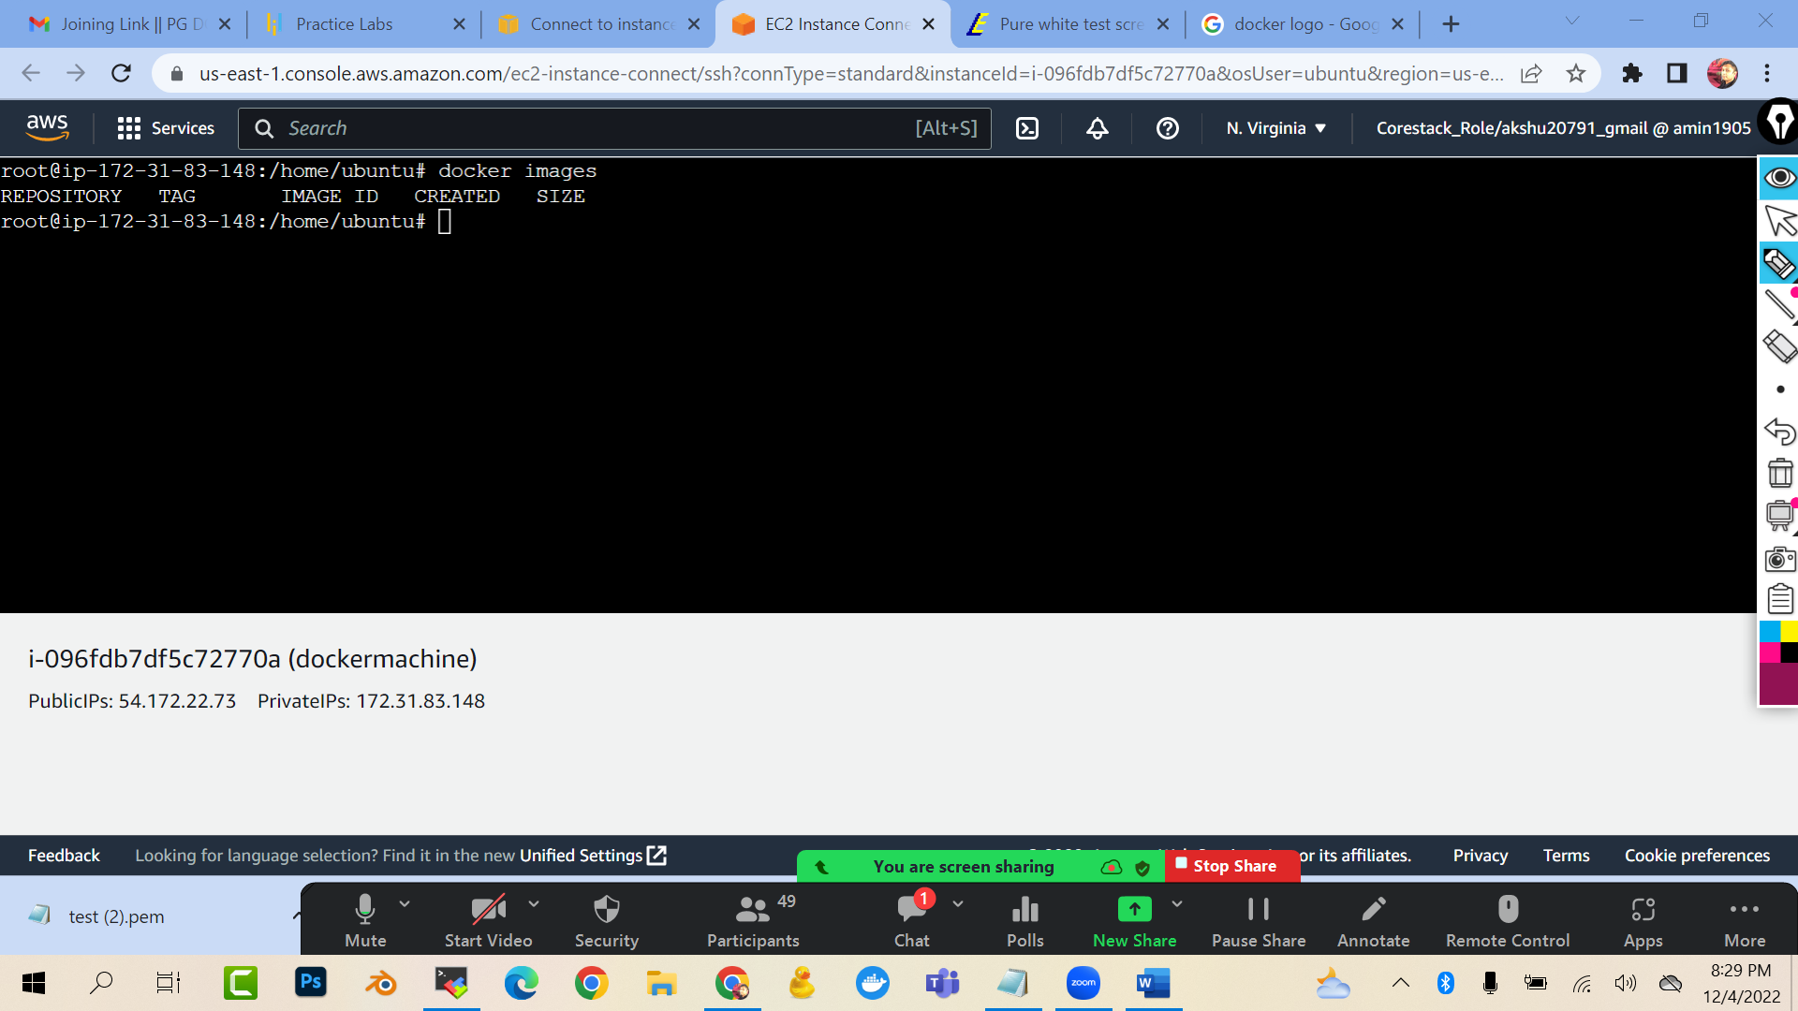

Create account on dockerhub

<https://hub.docker.com/_/redis>

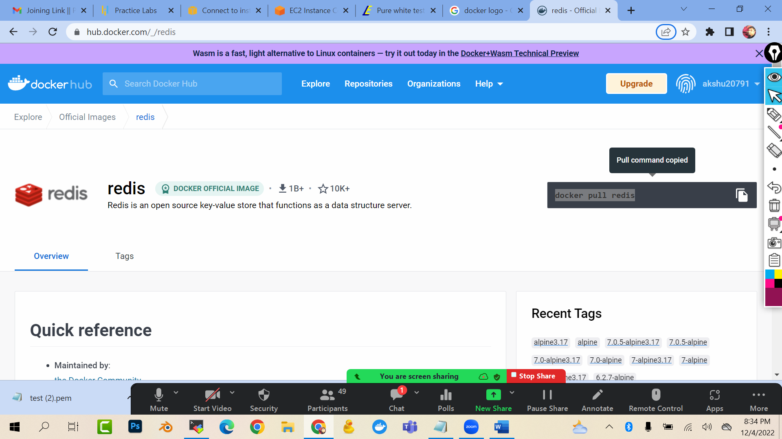

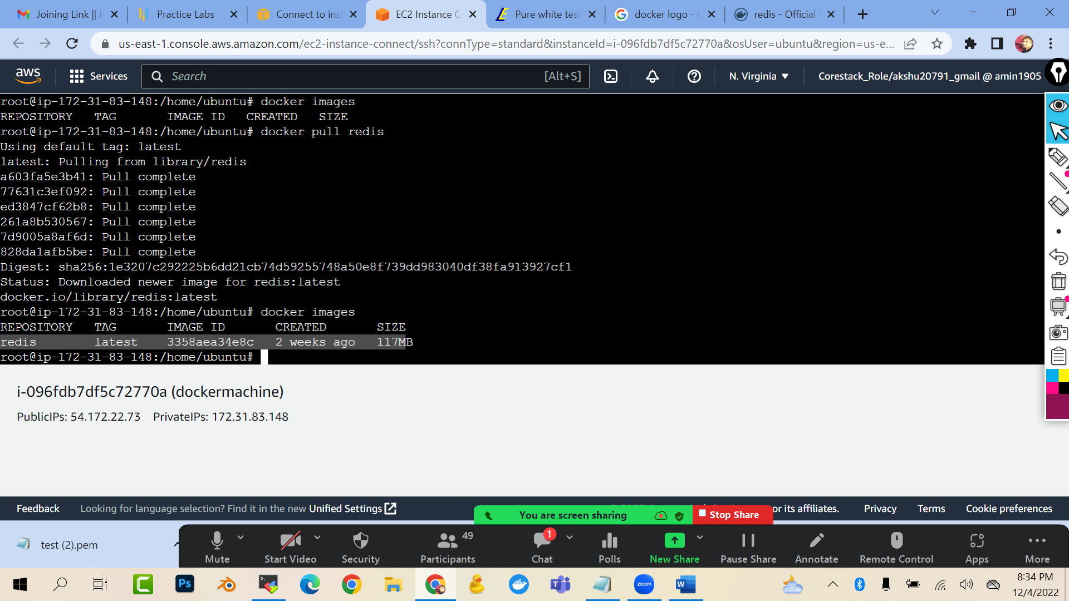

docker pull redis

docker images

### RIGHT NOW WE PULLED THE LATEST VERSION…BUT LETS SAY I DEVELOPER WANTS TO PULL THE SPECIFIC VERSION OF THE REDIS

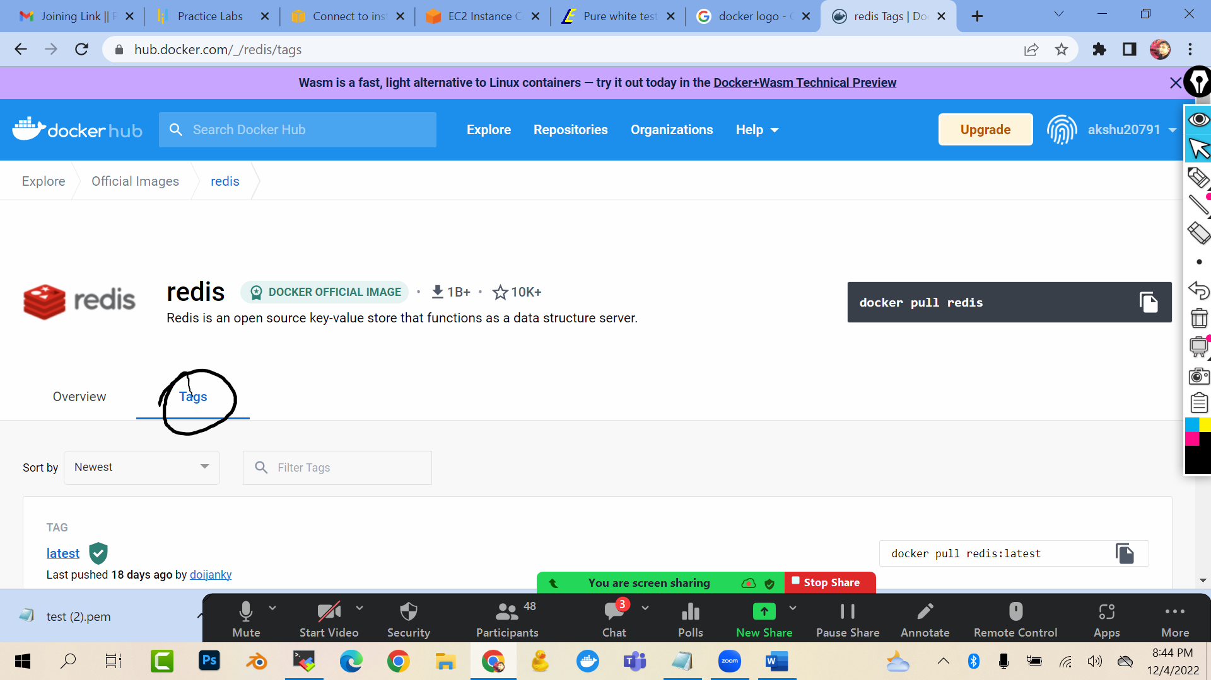

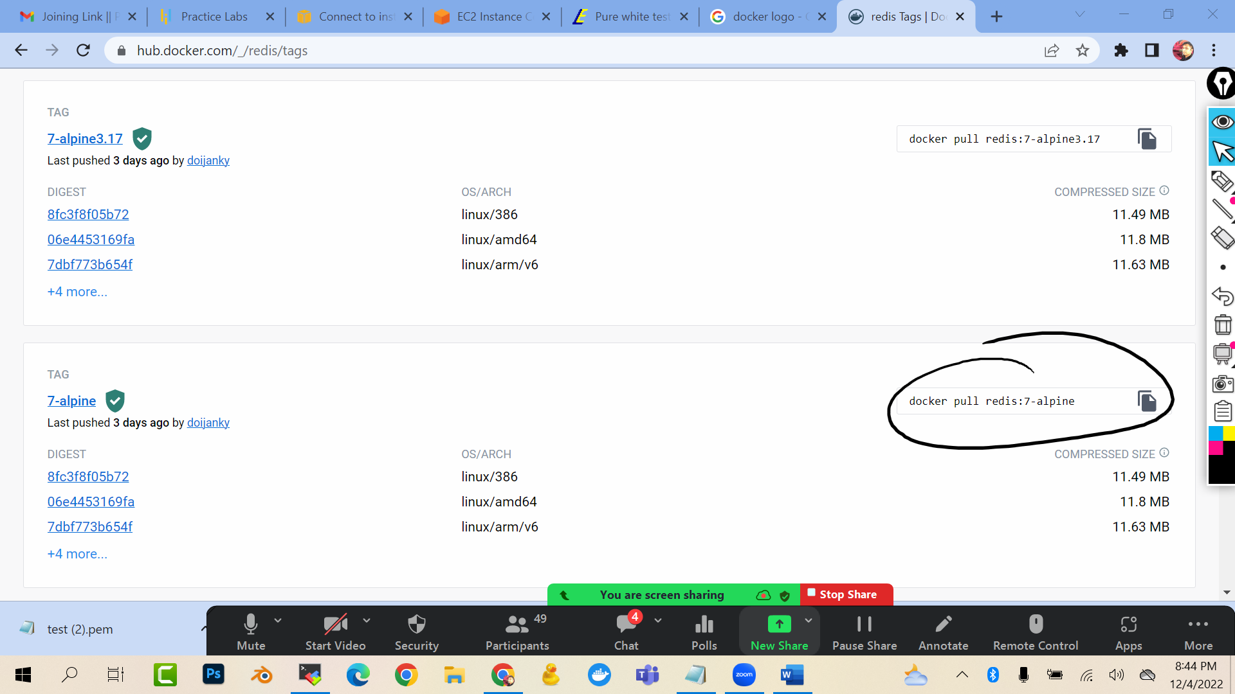

docker pull redis:7-alpine

docker images

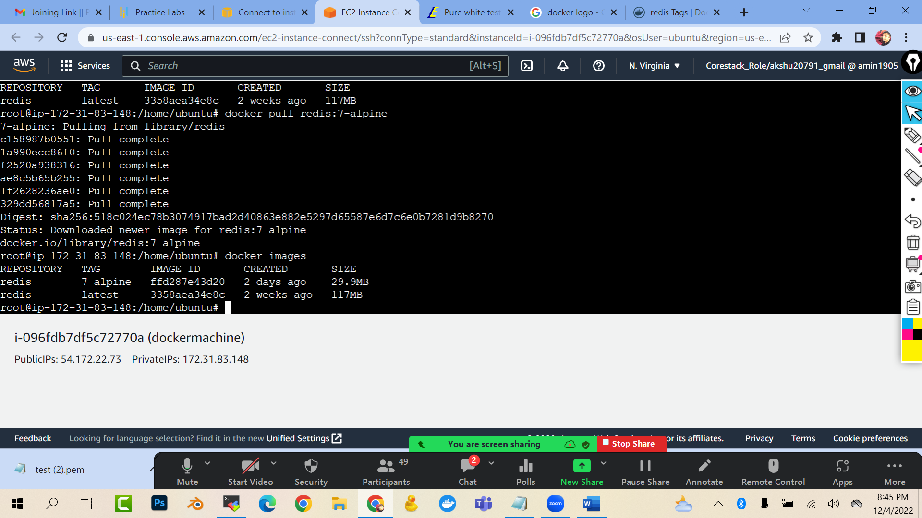

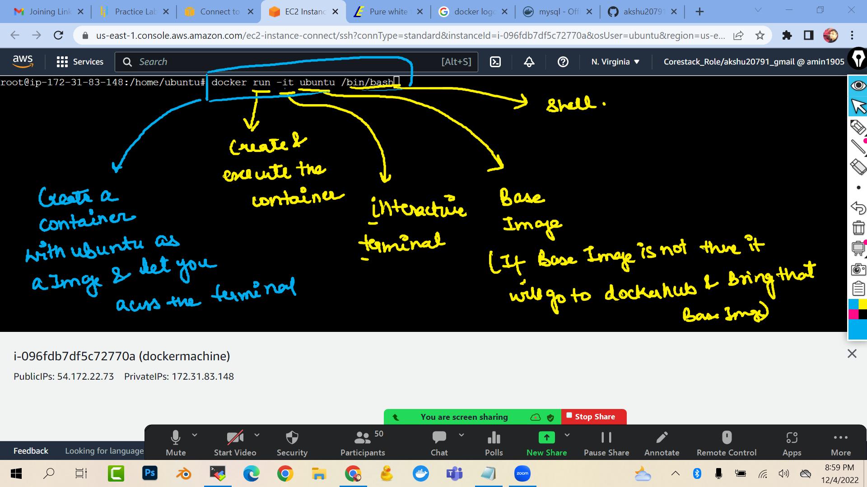

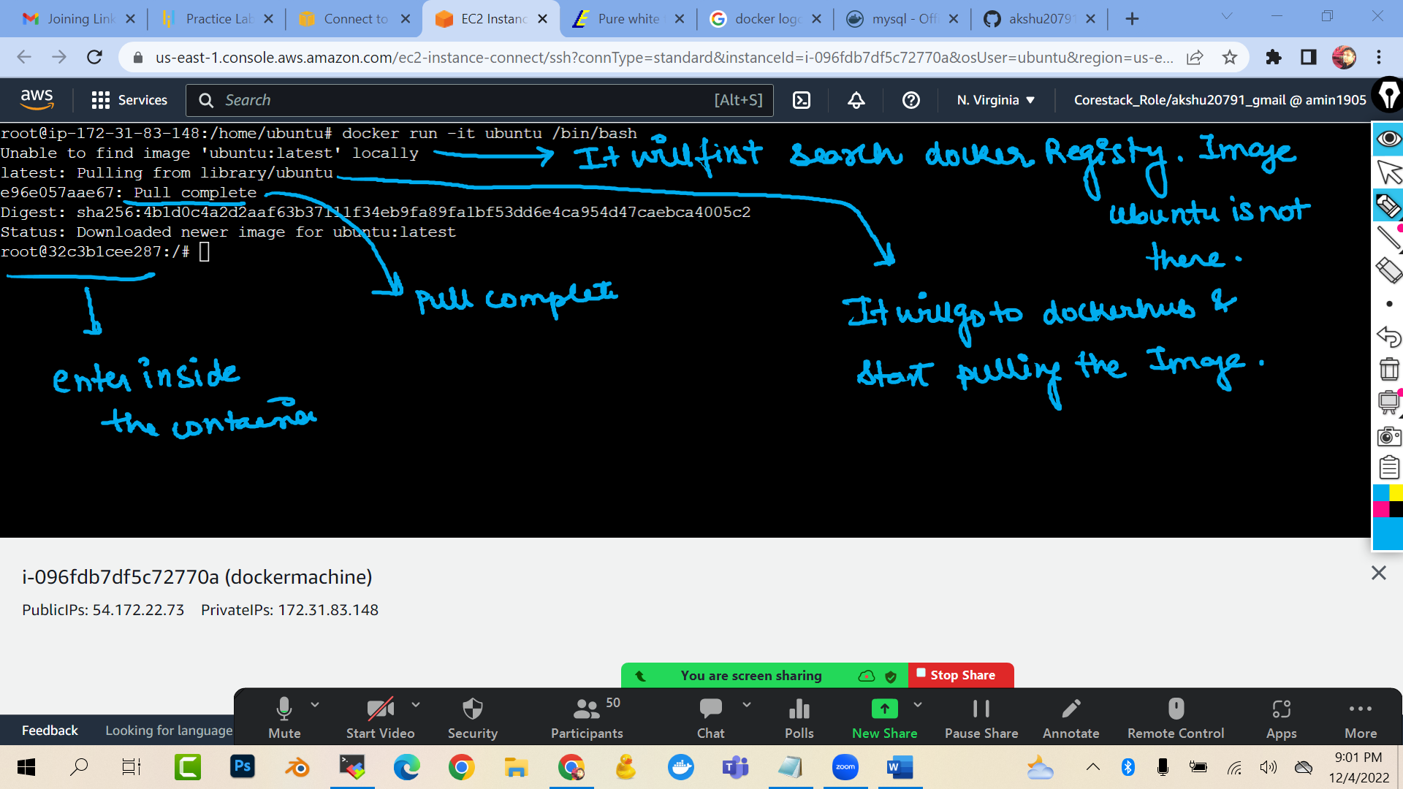

docker run -it ubuntu /bin/bash

(you will see that you have entered inside the container)

touch file1 file2 file3

ls

exit

ls

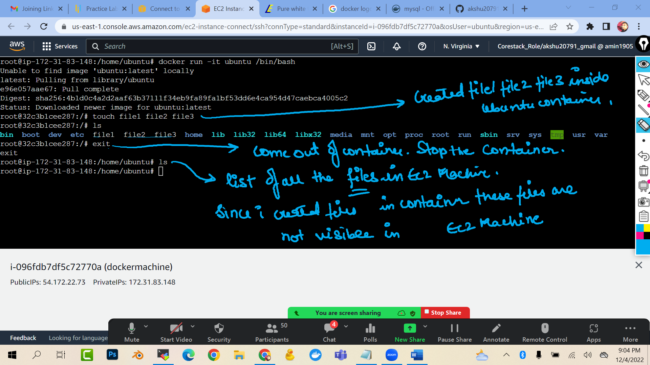

#### HOW TO LIST AND CHECK ALL THE CONTAINER ###############

docker ps -a

(ps: process)

(-a : all)

(it will list all the container for me)

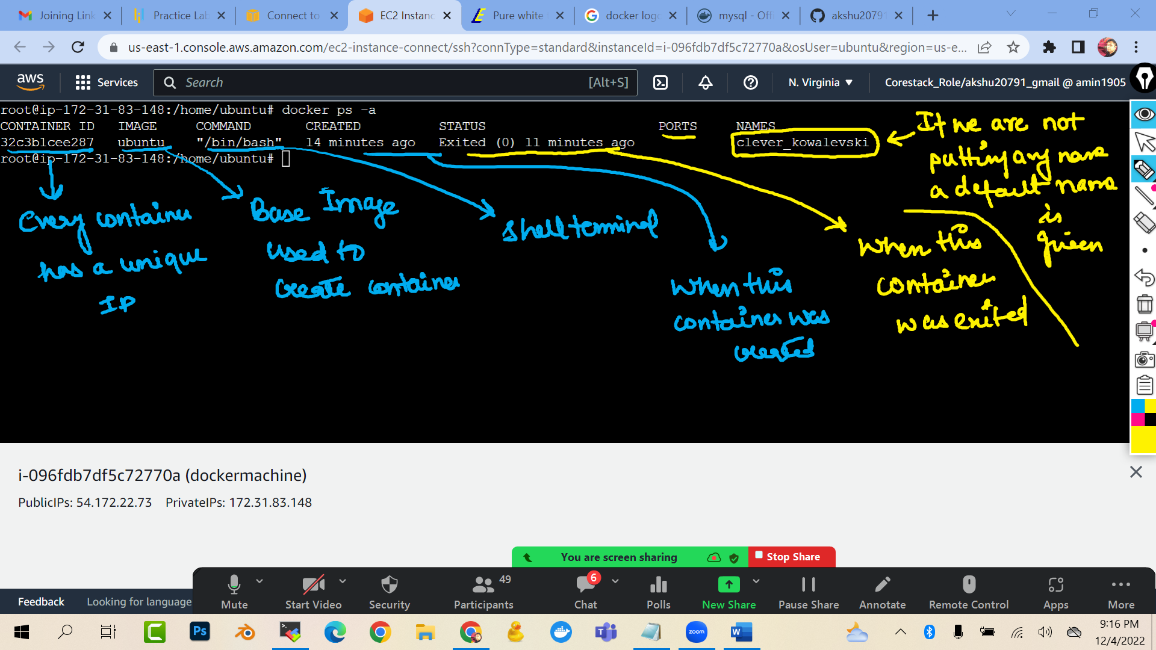

docker ps

(it will list only the running container)

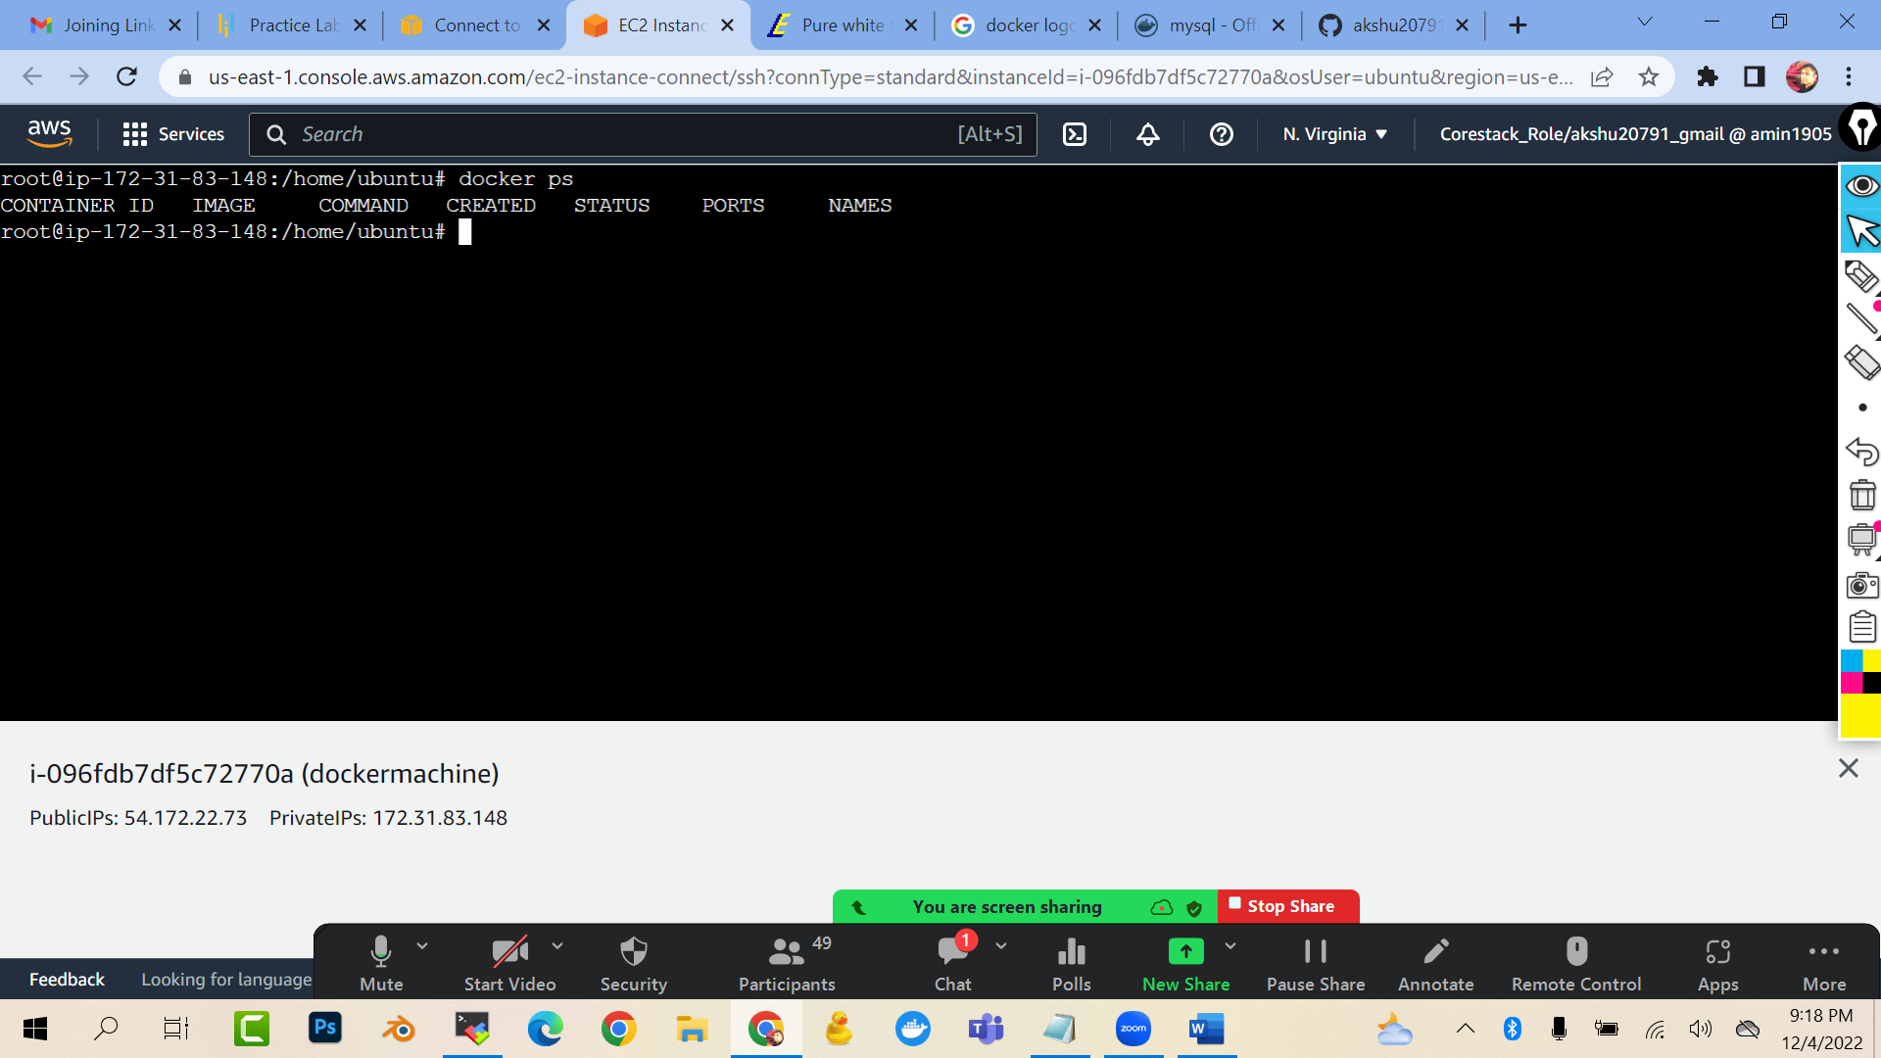

**###HOW CAN I START THE CONTAINER AND GET INSIDE THE CONTAINER ###############**

docker start <<name or id of your container>>

docker attach <<name or id of your container>>

(start : this command will start your container …attach : you will enter inside the container)

(you cannot attach to the stopped container)

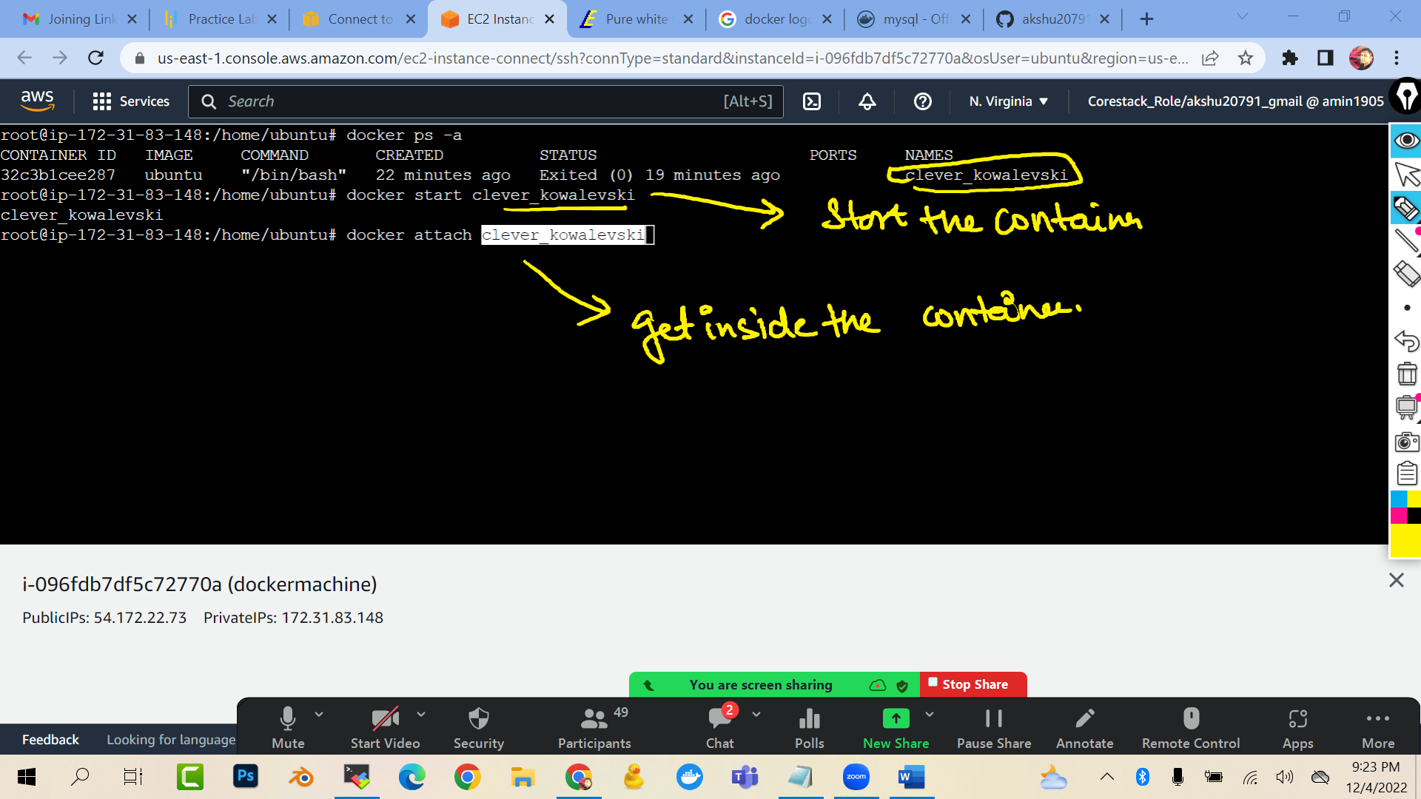

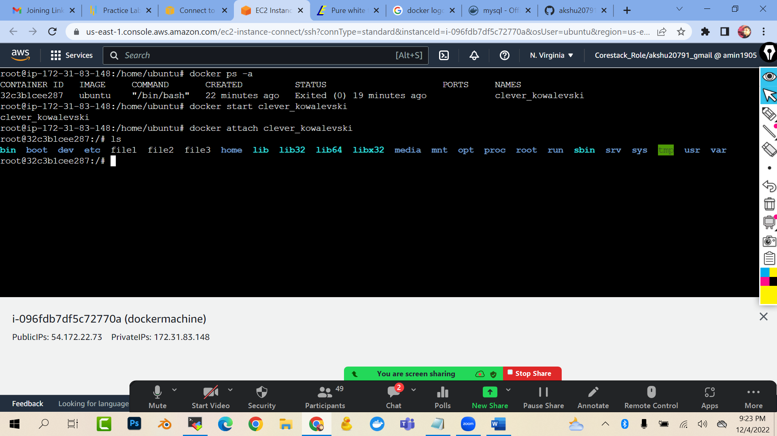

**## DOCKER CONTAINER WITH SOME CUSTOM NAMES ######**

docker run -it --name c01 ubuntu /bin/bash

(create a container with the name c01 and ubuntu as base image)

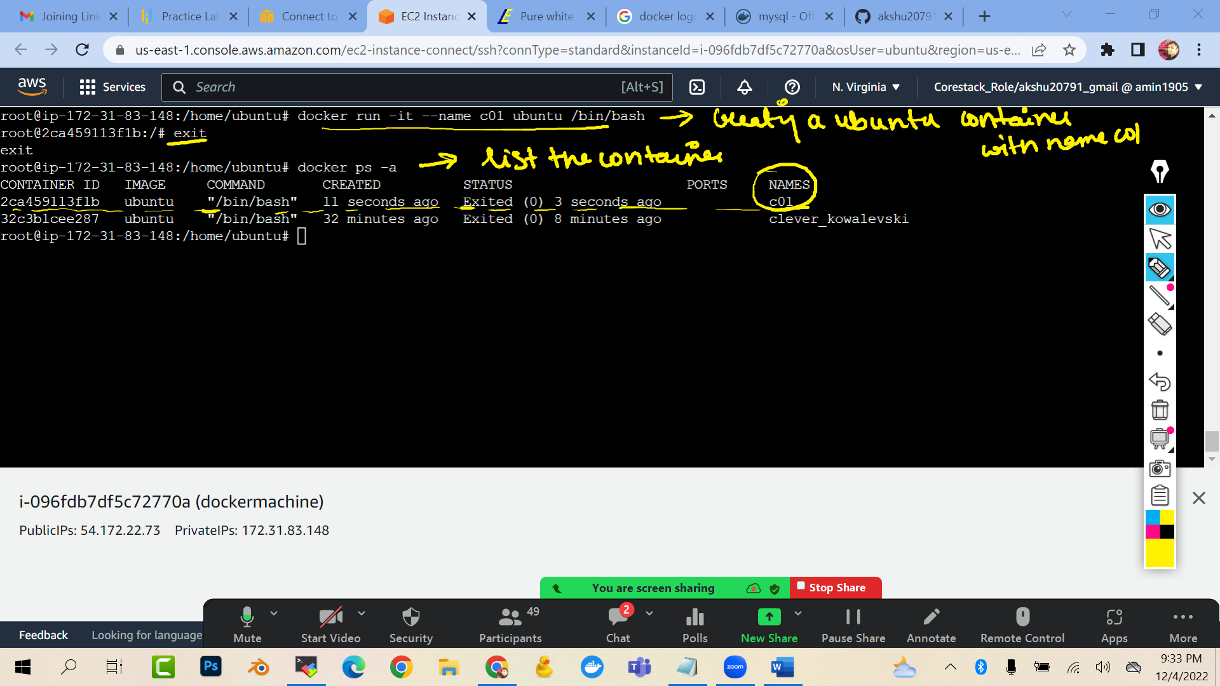

**#####HOW TO COME OUT OF CONTAINER WITHOUT STOPPING (WITHOUT USING THE EXIT COMMAND)####**

docker run -it --name c02 ubuntu /bin/bash  
you will enter inside the container

now rather then typing exit   
press ctrl p and ctrl q   
(save the process and quit the container)

###delete the container:

docker rm <<containername>>

##delete the image

You cannot delete the image which is been used currently by a container

docker rmi <<imagename>>

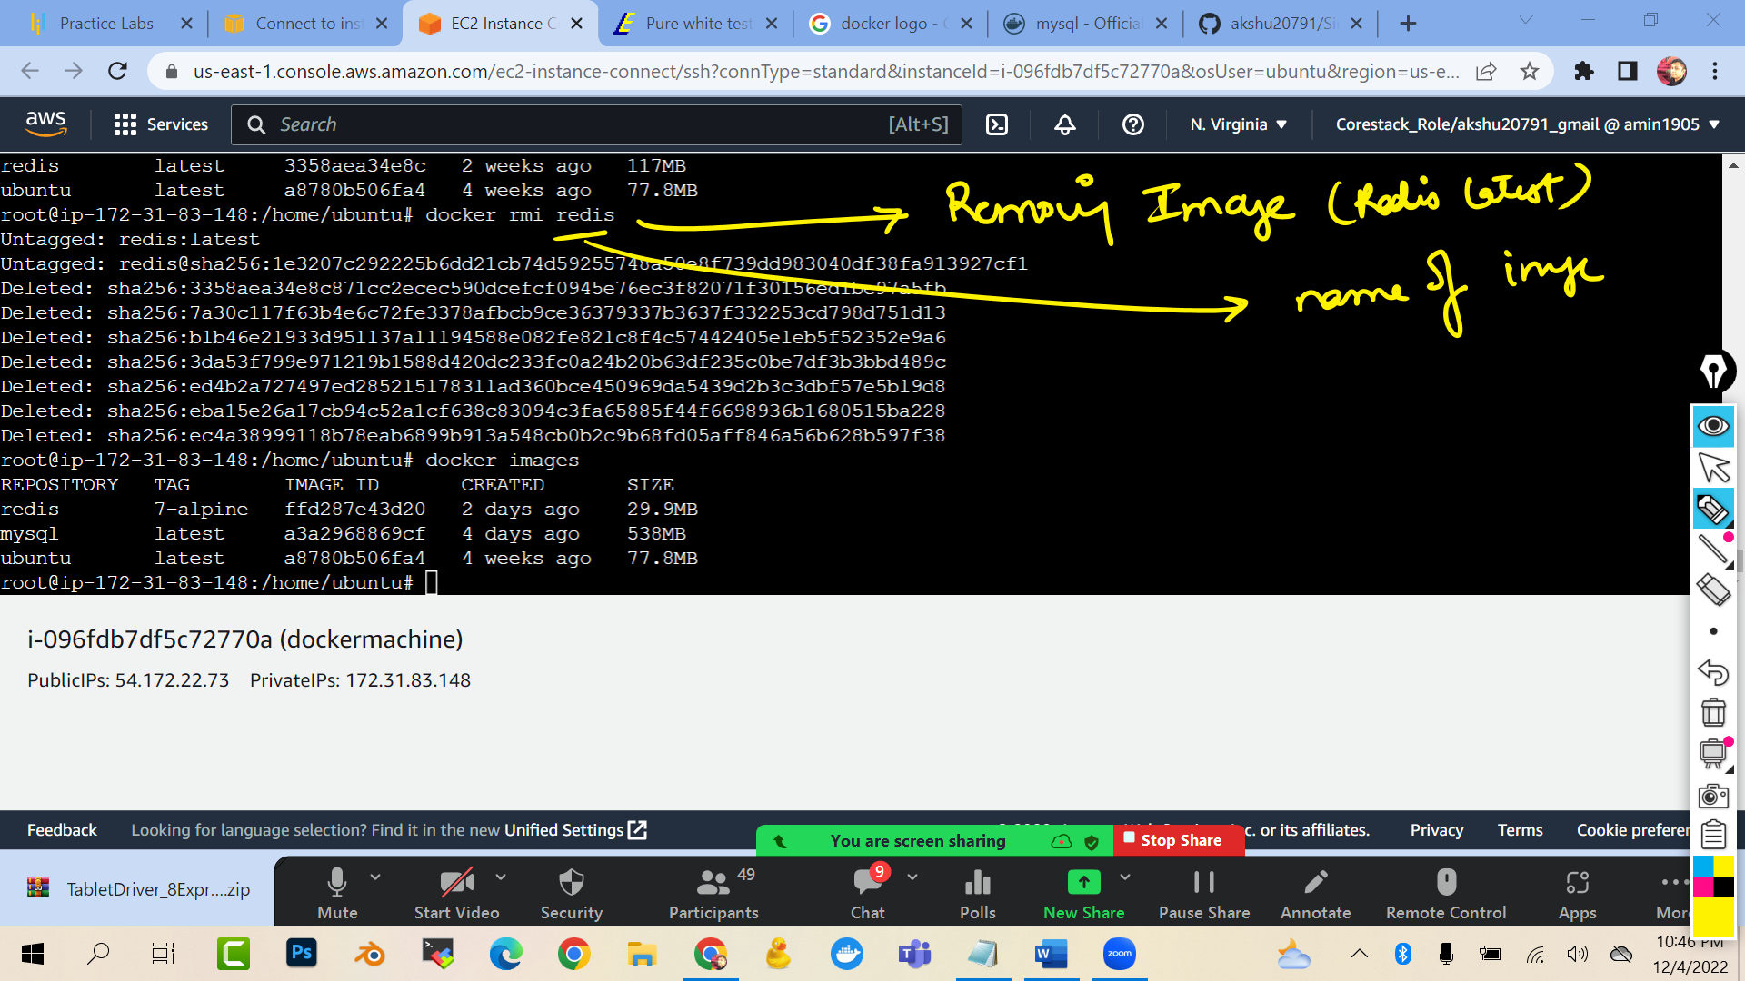

**#### HOW WE CAN CREATE A CUSTOM IMAGE FROM A CONTAINER ##############**

Lets say you have a container with some files in that. Now you want to create a replica of that container ,…how we will do it?

docker run -it --name c04 ubuntu /bin/bash

touch file1 file2 file3 file4 file5

ls

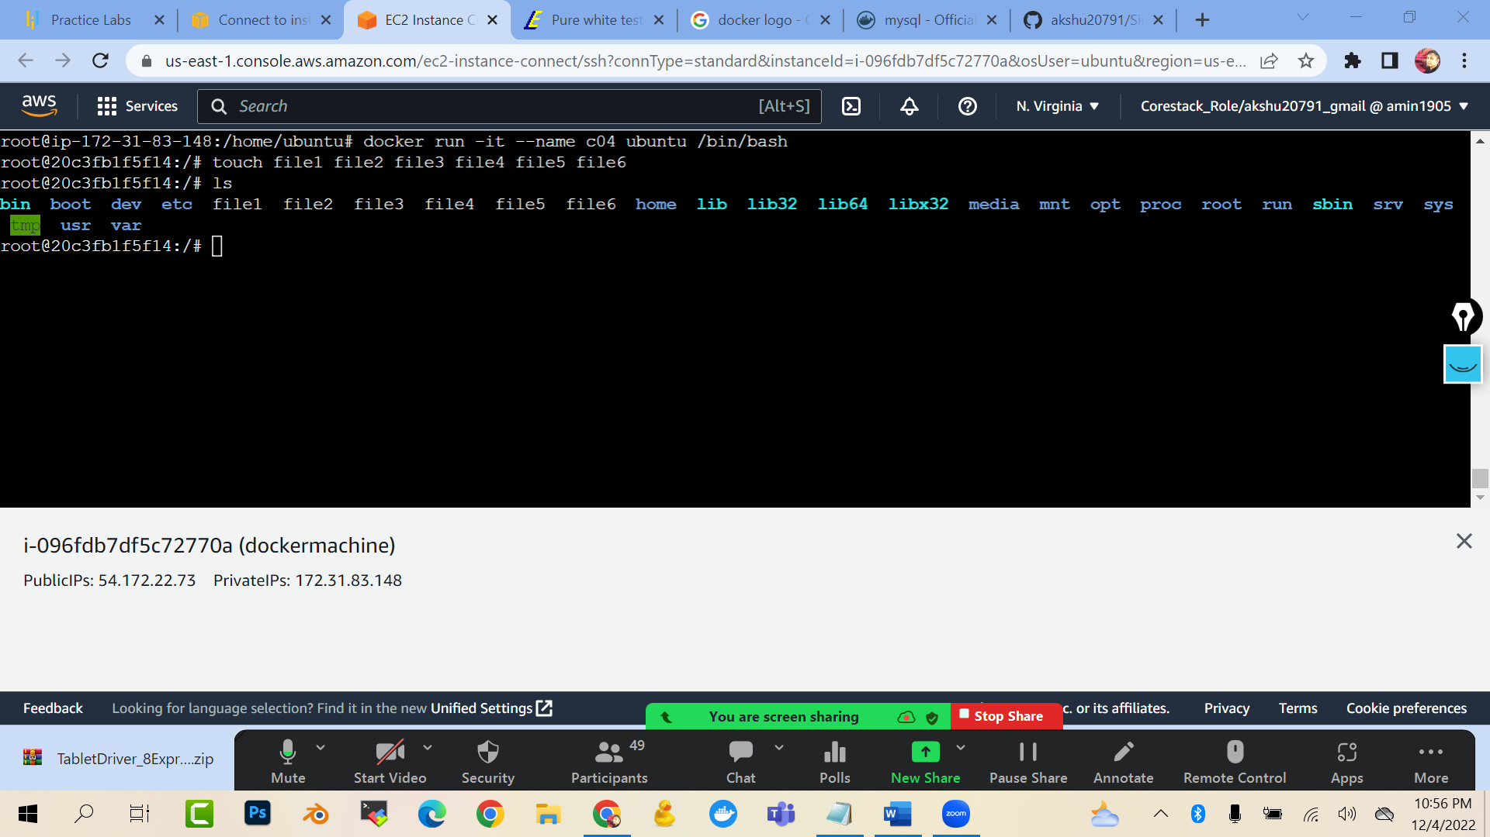

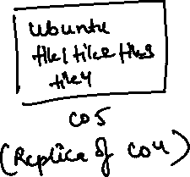

Now we need to create a custom image from the container c04

docker commit c04 customimg

(this command will create a custom image with name customimg which is the read only template (image) of the container c04)

docker images

(you will see that a image with name customimg is there)

docker run -it --name c05 customimg /bin/bash

(now we are creating a container c05 from the customimg as the base image)

ls (list)

you will see all the files …which we created in c04

